 | 3.3.2 Number of research papers per teachers in the Journals notified on UGC website during the year
 | Title of paper | Name of the author/s | Department of the teacher | Name of journal | Year of publication | ISSN number | Link to the recognition in UGC enlistment of the Journal
1 | Singh, B.P., Kumar, A., Singh, H. and Nagpal A. K., (2021) SOFT COMPUTING BASED IDENTIFICATION AND ASSESSMENT OF POTENTIAL DNA BARCODES OF SOLANACEOUS SPECIES USING cpDNA SEQUENCES. | Dr. Harpreet Singh | P.G Department of Bioinformatics | Indian Journal of Computer Science and Engineering (IJCSE). 12 (3), 641-652. (SCOPUS). | 2021 | 0976-5166 | 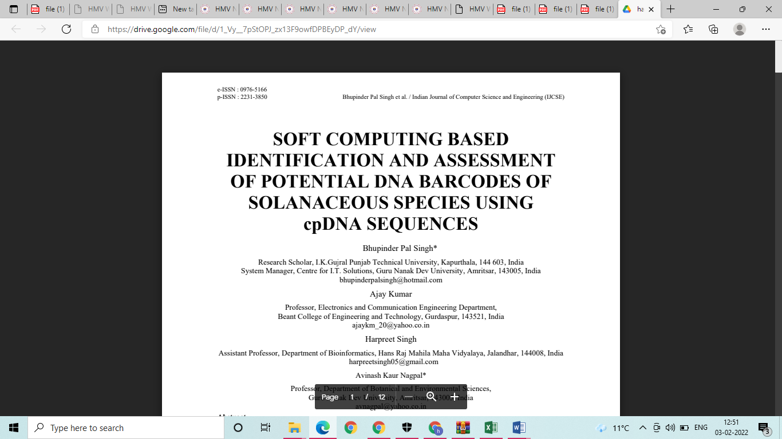
2 | Singh, M., Kaur, K., Sharma, A., Kaur, R., Joshi, D., Chatterjee, M., Dandapath, I., Kaur, A., Singh, H. and Singh, P., 2021. Genome-wide characterization of peptidyl-prolyl cis–trans isomerases in Penicillium and their regulation by salt stress in a halotolerant P. oxalicum. | Dr. Harpreet Singh | P.G Department of Bioinformatics | Scientific reports, 11(1), pp.1-19. | 2021 | 2045-2322 | 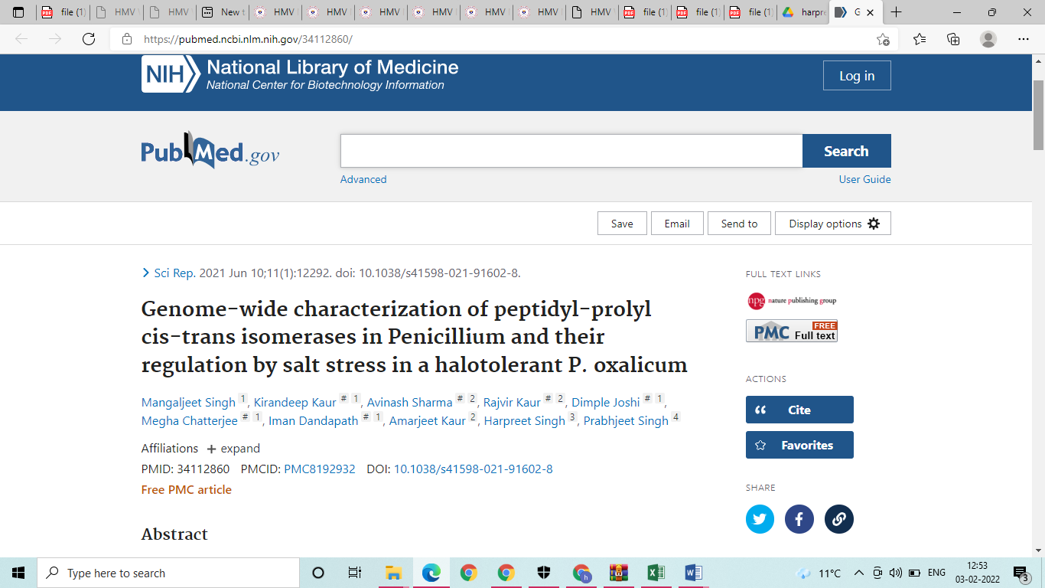
3 | Singh, H., Kaur, K., Singh, M., Kaur, G. and Singh, P., 2020. Plant cyclophilins: Multifaceted proteins with versatile roles. | Dr. Harpreet Singh | P.G Department of Bioinformatics | Frontiers in Plant Science, 11, Page: 1-30 (585212). | 2020 | 1664-462X, | 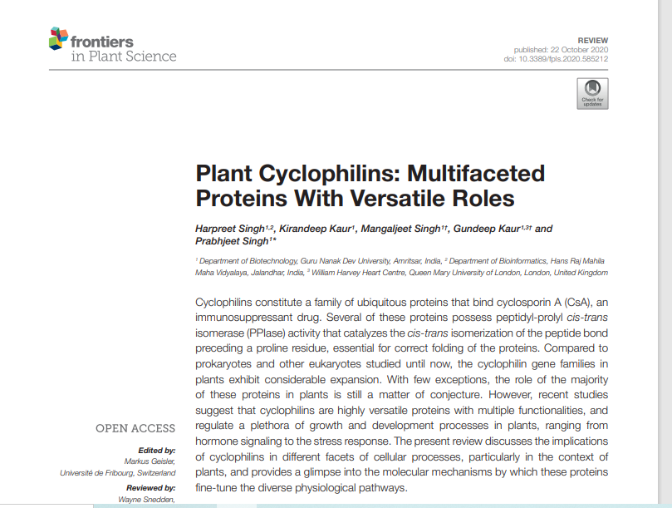
4 | Dutta, T., Singh, H., Gestwicki, J.E. and Blatch, G.L., 2021. Exported plasmodial J domain protein, PFE0055c, and PfHsp70-x form a specific co-chaperone-chaperone partnership. | Dr. Harpreet Singh | P.G Department of Bioinformatics | Cell Stress and Chaperones, 26, 355–366. | 2020 | 1355-8145 | 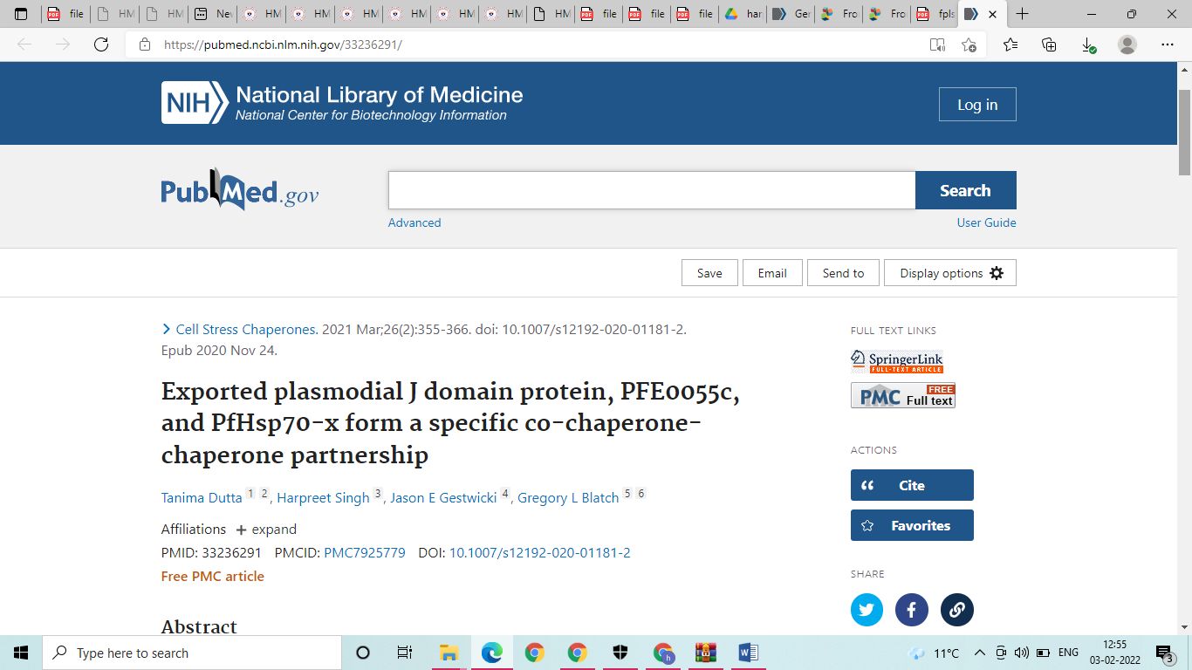
5 | Kaur, J. (2020). Sources of information used by Equity Investors: A study of Punjab, | Dr. Jaspreet Kaur | PG Department of Commerce & Management | Pacific business review international. Vol. 13, Issue 5, | 2020 | 0974-438X | 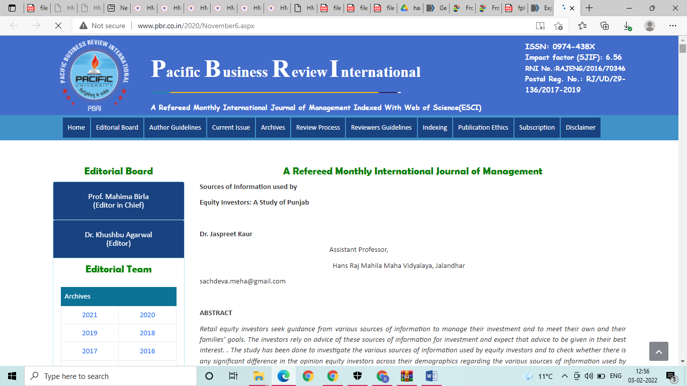
6 | • Kaur, J. and Singh, B. (Jan-March, 2021). Factors Influencing Saving Habits among Individuals: A Study of Northern India. | Dr. Jaspreet Kaur | PG Department of Commerce & Management | The Orissa Journal of Commerce. Vol. 42, Issue 1, | 2020 | 0974-8482 | 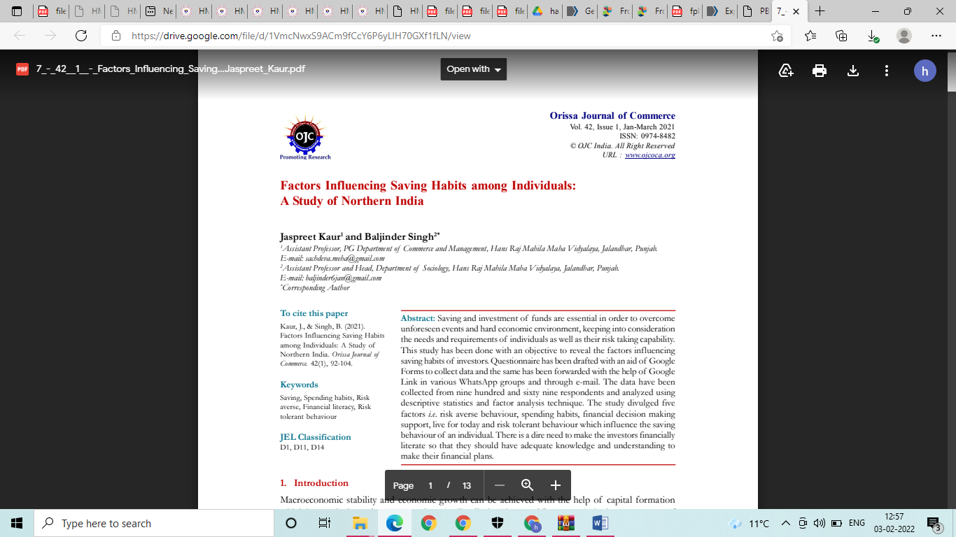
7 | Employee Empowerment Strategies: Key To Job Satisfaction Among Private Universities Teachers in Punjab, INDIA | Mrs.Kajal | PG Department of Commerce & Management | JOURNAL OF CRITICAL REVIEWS, Vol 7 issue | Jul-05 | 2394-5125 | 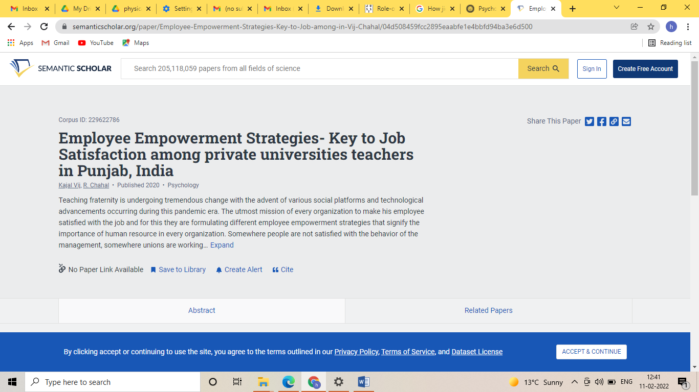
8 | HR Strategy With Reference To Employee Empowerment And Job Satisfaction | Mrs.Kajal | PG Department of Commerce & Management | Science, Technology and Development Journal, VOL X Issue II | Jul-05 | 0950-0707 | 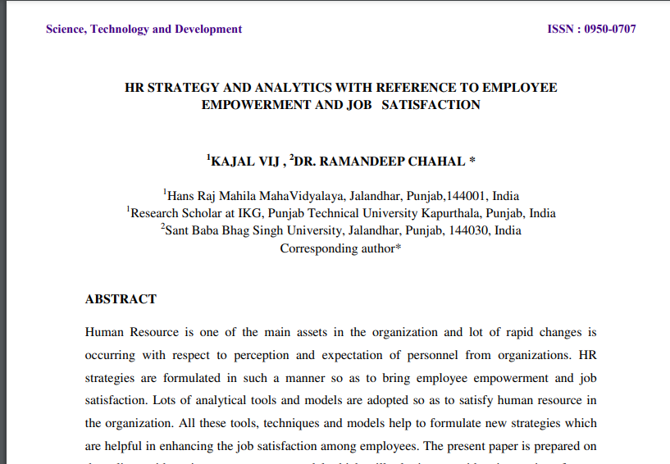
9 | Modeling spiritual intelligence on  quality of work life of college  teachers: a mediating role of  psychological capital | Dr. Meenakshi Duggal | PG Department of Commerce & Management | International Journal of Quality  and Service Sciences  DOI 10.1108/IJQSS-07-2020-0108 | 2021 | 1756-669X | 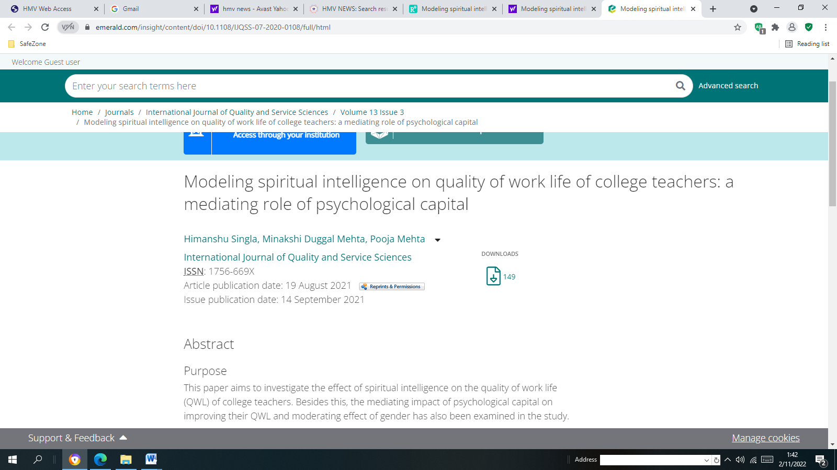
10 | “Physiochemical Characterization of Oil Extracted from Microalgae Chlorella Pyrenoidosa”, | Mrs. Ramandeep Kaur | PG Department of Botany | Journal of University of Shanghai for Science and Technology | 2021 | 1007-6735 | 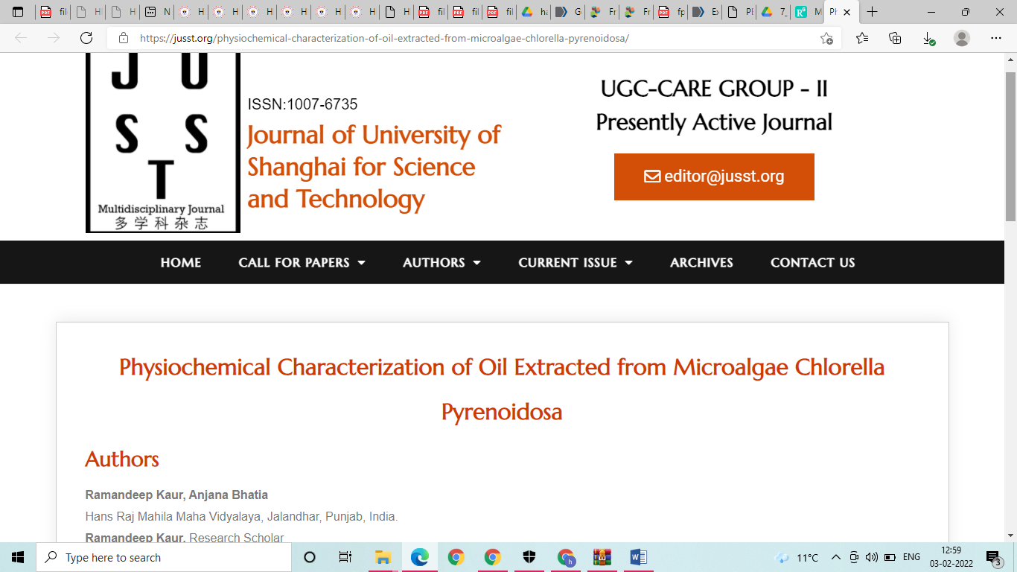
11 | “Physiochemical Characterization of Oil Extracted from Microalgae Chlorella Pyrenoidosa”, | Dr . Anjana Bhatia | PG Department of Botany | Journal of University of Shanghai for Science and Technology | 2021 | 1007-6735
12 | Studying regenerative competence of Satyrium nepalense D.Don through leaf segments in vitro | Dr. Anjana Bhatia | PG Department of Botany | Research journal of Biotechnology | 2021 | 2278-4535
13 | Rigveda Samhita mein varnit prantatva vishyak charcha | Dr. Meenu Talwar | Department of Sanskrit | Vishyak charcha ek adhyan | 2021 | 2349-364X
14 | Psycho-social Aspects of the Non-marital Relationships: A Comparative  Study of Rabindranath Tagore’s and Gurdial Singh’s Selected Short Stories | Mrs. Mamta | PG Department of English | PSYCHOLOGY AND EDUCATION | 2021 | 1553 - 6939 | 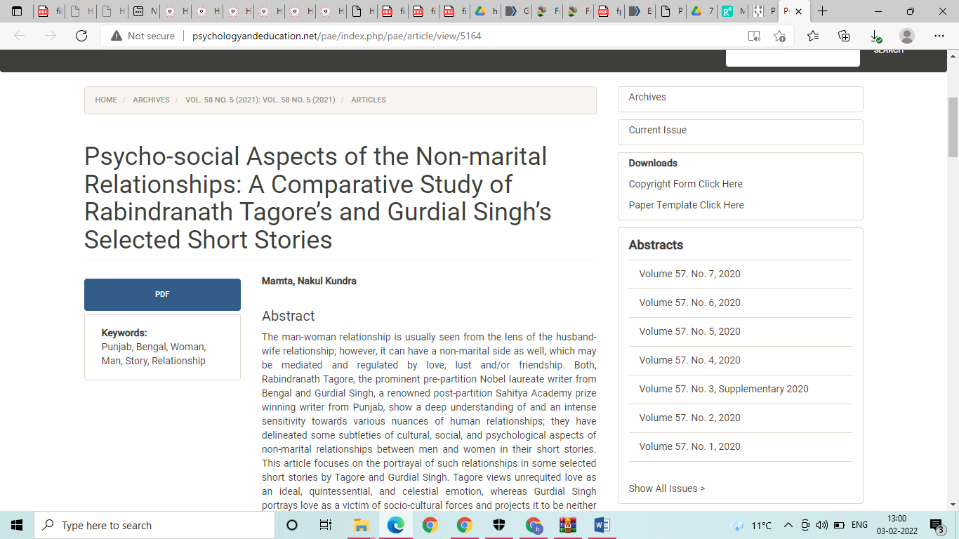
15 | How jio mart used swot analysis to gain a competitive edge | Mrs. Savita Mahindru | PG Department of Commerce & Management | Wesleyan journal of research | 2021 | 0975-1386
16 | Thermal creep stress analysis of functionally graded spherical shell under internal and external pressure | Dr. Gaurav Verma | PG Department of Mathematics | Structural Integrity and life | 2021 | 1451-3749 | 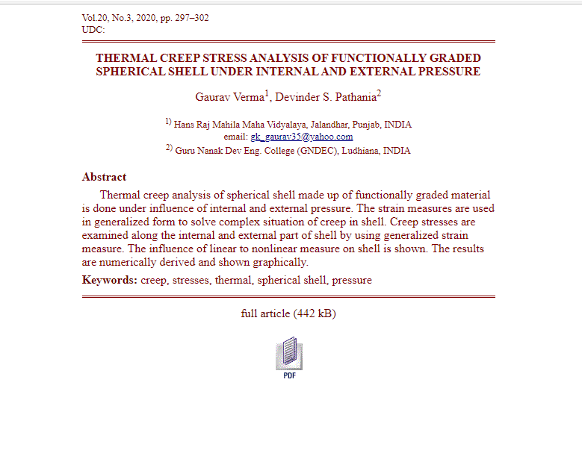
17 | Rattan A, Kapoor, D, Kapoor, N, Bhardwaj, R and Sharma, A (2020). Brassinosteroids Regulate Functional Components of Antioxidative Defense System in Salt Stressed Maize Seedlings | Dr. Nitika Kappor | PG Department of Botany | Journal of Plant Growth Regulation | 2021 | 1435-8107 | 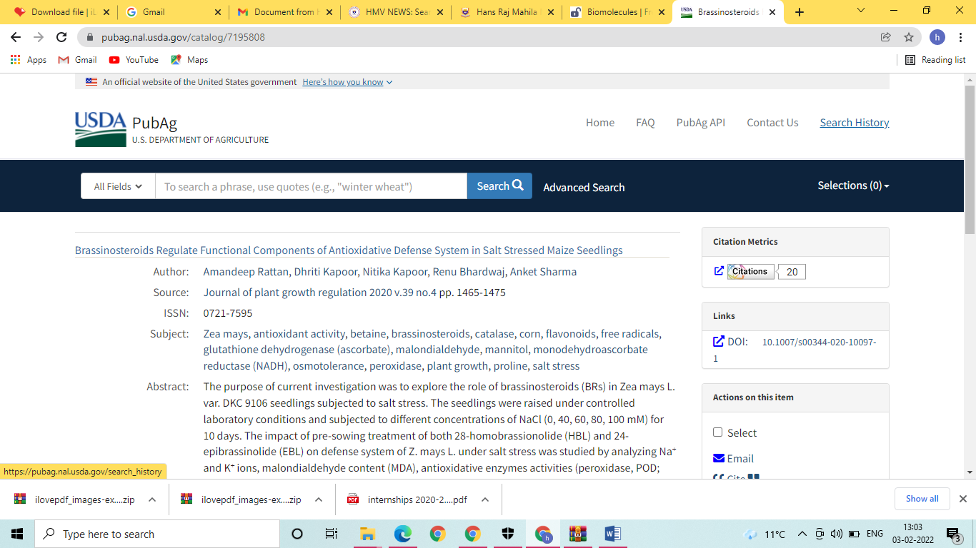
18 | Kaur, R. and Kapoor, N. (2021). Role of Amino Acids other than Proline in Abiotic Stress Amelioration in Plants. | Dr. Nitika Kappor | PG Department of Botany | Journal of University of Shanghai for Science and Technology | 2021 | : 1007-6735 | 